MGMS –Fund Receipt

Detailed Design Document

Ver. 1.4

Version History
Date | Description
21-Nov-2010 | First draft

Table of Contents

Version History 2
1 Introduction 4
2 Fund Receipt 4
3 Associated Tables 7
4 Data Dictionary 7

Introduction

This document provides the detailed design specifications for the Multisite Grant Management System project.

This is not a project plan nor does it detail the source code. It is a guide for system architecture and development, not for phasing, timelines or deliverables.

Finally, this is a ‘living document’ and the specification will change, continuously, as the project proceeds. More details will be added and the existing information edited as the requirements, architecture and design evolve in the course of the project.

Fund Receipt
This is a record of acknowledgement of amount received.

- A receipt may be recorded by;
  - An account head which received an amount against the allocation made to it by its institution.
  - An account head of a grantee institution which received an amount (fund transfer) against the sub-allocation made to it by the grantor institution for a project.
    - The details associated with a grant receipt are: amount, date of receipt, funds received order no:, grant allocation against which fund was transferred, fund transferred against which grant was received, receiving account head name, mode of payment and related details (Cash/DD/cheque details, bank details etc)
    - Each grant receipt may be tracked by fund received Order no.
    - The information maybe updated later

Screen & Control Description

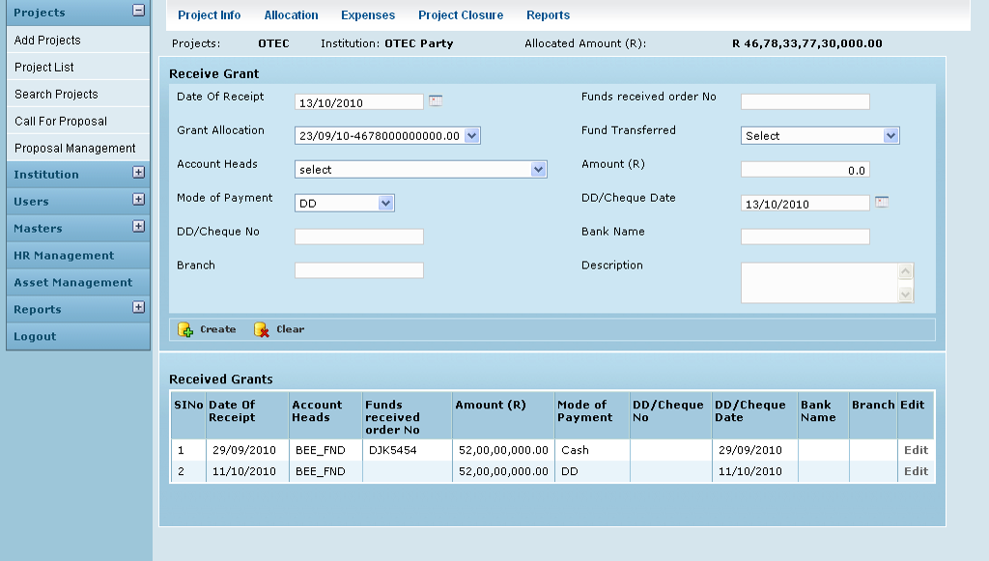

Field /Label | Input-Control | Data Type | Remarks /db table>field
Projects: | Auto populated | varchar(255) | projects>code
Institution: | Auto populated | varchar(255) | party>code
Allocated Amount (R) | Auto populated | double | grant_allocation>amount_allocated
Receive Grant
Date of Receipt | Calendar | datetime | grant_receipt>date_of_receipt
Funds received order no: | Textbox | varchar(255) | grant_receipt>reference_id
Grant Allocation: | Listbox | varchar(255) | grant_allocation>date_of_allocation -grant_allocation>amount_allocated
Fund Transferred | Listbox | double | fund_transfer>amount
Account Heads | Listbox | varchar(255) | account_heads>name
Amount (R) | Textbox | double | grant_receipt>amount
Mode of Payment | Textbox | varchar(255) | grant_receipt>mode_of_payment
DD/Cheque No: | Textbox | varchar(255) | grant_receipt>dd_no
DD/Cheque Date | Calendar | datetime | grant_receipt>dd_date
Bank Name | Textbox | varchar(255) | grant_receipt>bank_name
Branch | Textbox | varchar(255) | grant_receipt>dd_branch
Description | Textarea | varchar(255) | grant_receipt>description
Create |  |  | A grant receipt record is saved
Clear |  |  | Clears fields
Received Grants
Sl No
Date of Receipt | Auto populated | datetime | grant_receipt>date_of_receipt
Account Heads | Auto populated | varchar(255 | account_heads>name
Funds received order no: | Auto populated | varchar(255 | grant_receipt>reference_id
Amount (R) | Auto populated | double | grant_receipt>amount
Mode of Payment | Auto populated | varchar(255) | grant_receipt>mode_of_payment
DD/Cheque No: | Auto populated | varchar(255) | grant_receipt>dd_no
DD/Cheque Date | Auto populated | datetime | grant_receipt>dd_date
Bank Name | Auto populated | varchar(255) | grant_receipt>bank_name
Branch | Auto populated | varchar(255) | grant_receipt>dd_branch
Edit | Button

Edit Grant Receipt

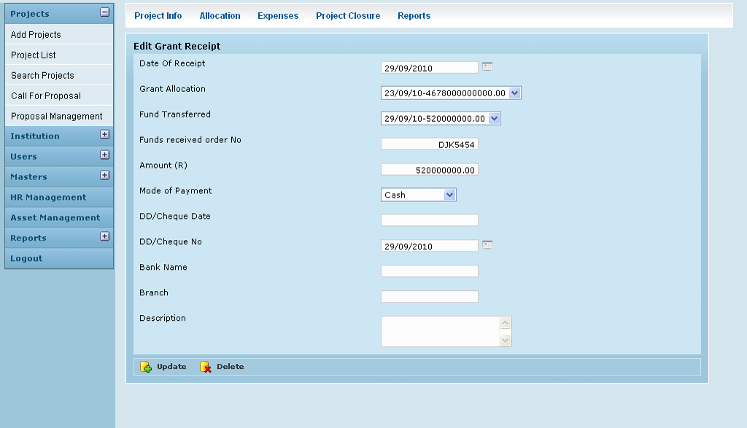

Field /Label | Input-Control | Data Type | Remarks / db table>field
Edit Grant Receipt
Date of Receipt | Calendar | datetime | grant_receipt>date_of_receipt
Funds received order no: | Textbox | varchar(255) | grant_receipt>reference_id
Grant Allocation: | Listbox | varchar(255) | grant_allocation>date_of_allocation -grant_allocation>amount_allocated
Fund Transferred | Listbox | double | fund_transfer>amount
Amount (R) | Listbox | double | grant_receipt>amount
Mode of Payment | Textbox | varchar(255) | grant_receipt>mode_of_payment
DD/Cheque No: | Textbox | varchar(255) | grant_receipt>dd_no
DD/Cheque Date | Textbox | datetime | grant_receipt>dd_date
Bank Name | Calendar | varchar(255) | grant_receipt>bank_name
Branch | Textbox | varchar(255) | grant_receipt>dd_branch
Description | Textbox | varchar(255) | grant_receipt>description
Create | Button |  | Grant receipt record changes saved
Delete | Button |  | Removes the entry

Associated Tables

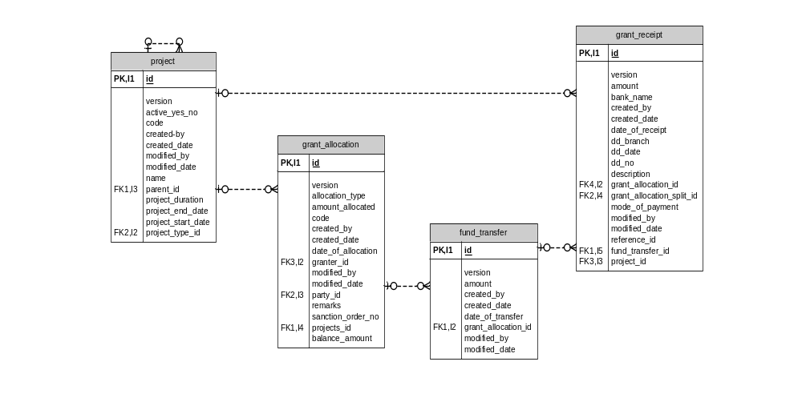

Data Dictionary

grant_allocation

Fields

Field | Type | Collation | Null | Key | Default | Extra | Privileges
id | bigint(20) | (NULL) | NO | PRI | (NULL) | auto_increment | select,insert,update,references
version | bigint(20) | (NULL) | NO |  |  |  | select,insert,update,references
allocation_type | varchar(255) | latin1_swedish_ci | NO |  |  |  | select,insert,update,references
amount_allocated | double | (NULL) | NO |  |  |  | select,insert,update,references
code | varchar(255) | latin1_swedish_ci | NO |  |  |  | select,insert,update,references
created_by | varchar(255) | latin1_swedish_ci | NO |  |  |  | select,insert,update,references
created_date | datetime | (NULL) | YES |  | (NULL) |  | select,insert,update,references
date_of_allocation | datetime | (NULL) | NO |  |  |  | select,insert,update,references
granter_id | bigint(20) | (NULL) | YES | MUL | (NULL) |  | select,insert,update,references
modified_by | varchar(255) | latin1_swedish_ci | NO |  |  |  | select,insert,update,references
modified_date | datetime | (NULL) | YES |  | (NULL) |  | select,insert,update,references
party_id | bigint(20) | (NULL) | NO | MUL |  |  | select,insert,update,references
projects_id | bigint(20) | (NULL) | NO | MUL |  |  | select,insert,update,references
remarks | varchar(255) | latin1_swedish_ci | NO |  |  |  | select,insert,update,references
sanction_order_no | varchar(255) | latin1_swedish_ci | YES |  | (NULL) |  | select,insert,update,references

Indexes

Table | Non  unique | Key  name | Seq  in  index | Column  name | Collation | Cardinality | Sub  part | Packed | Null | Index  type | Comment
grant_allocation | 0 | PRIMARY | 1 | id | A | 433 | (NULL) | (NULL) |  | BTREE
grant_allocation | 1 | FK221B5BE337914517 | 1 | granter_id | A | 48 | (NULL) | (NULL) | YES | BTREE
grant_allocation | 1 | FK221B5BE34B78CFDA | 1 | party_id | A | 108 | (NULL) | (NULL) |  | BTREE
grant_allocation | 1 | FK221B5BE3905C4B9A | 1 | projects_id | A | 433 | (NULL) | (NULL) |  | BTREE

Foreign Key Relationships

FK Id | Reference Table | Source Column | Target Column | Extra Info
FK221B5BE3905C4B9A | projects | `projects_id` | `id` | ,
FK221B5BE337914517 | party | `granter_id` | `id` | ,
FK221B5BE34B78CFDA | party | `party_id` | `id`

projects

Fields

Field | Type | Collation | Null | Key | Default | Extra | Privileges
id | bigint(20) | (NULL) | NO | PRI | (NULL) | auto_increment | select,insert,update,references
version | bigint(20) | (NULL) | NO |  |  |  | select,insert,update,references
active_yes_no | char(1) | latin1_swedish_ci | NO |  |  |  | select,insert,update,references
code | varchar(255) | latin1_swedish_ci | NO |  |  |  | select,insert,update,references
created_by | varchar(255) | latin1_swedish_ci | NO |  |  |  | select,insert,update,references
created_date | datetime | (NULL) | NO |  |  |  | select,insert,update,references
modified_by | varchar(255) | latin1_swedish_ci | NO |  |  |  | select,insert,update,references
modified_date | datetime | (NULL) | NO |  |  |  | select,insert,update,references
name | varchar(255) | latin1_swedish_ci | NO |  |  |  | select,insert,update,references
parent_id | bigint(20) | (NULL) | YES | MUL | (NULL) |  | select,insert,update,references
project_duration | varchar(255) | latin1_swedish_ci | YES |  | (NULL) |  | select,insert,update,references
project_end_date | datetime | (NULL) | YES |  | (NULL) |  | select,insert,update,references
project_start_date | datetime | (NULL) | YES |  | (NULL) |  | select,insert,update,references
project_type_id | int(11) | (NULL) | NO | MUL |  |  | select,insert,update,references

Indexes

Table | Non  unique | Key  name | Seq  in  index | Column  name | Collation | Cardinality | Sub  part | Packed | Null | Index  type | Comment
projects | 0 | PRIMARY | 1 | id | A | 137 | (NULL) | (NULL) |  | BTREE
projects | 1 | FKC479187A69DF6AED | 1 | project_type_id | A | 8 | (NULL) | (NULL) |  | BTREE
projects | 1 | FKC479187A43BA2D6A | 1 | parent_id | A | 137 | (NULL) | (NULL) | YES | BTREE

Foreign Key Relationships

FK Id | Reference Table | Source Column | Target Column | Extra Info
FKC479187A43BA2D6A | projects | `parent_id` | `id` | ,
FKC479187A69DF6AED | project_type | `project_type_id` | `id`
grant_receipt

Fields

Field | Type | Collation | Null | Key | Default | Extra | Privileges
id | bigint(20) | (NULL) | NO | PRI | (NULL) | auto_  increment | select,insert,update,references
version | bigint(20) | (NULL) | NO |  |  |  | select,insert,update,references
amount | double | (NULL) | NO |  |  |  | select,insert,update,references
bank_name | varchar(255) | latin1_swedish_ci | YES |  | (NULL) |  | select,insert,update,references
created_by | varchar(255) | latin1_swedish_ci | NO |  |  |  | select,insert,update,references
created_date | datetime | (NULL) | NO |  |  |  | select,insert,update,references
date_of_receipt | datetime | (NULL) | NO |  |  |  | select,insert,update,references
dd_branch | varchar(255) | latin1_swedish_ci | YES |  | (NULL) |  | select,insert,update,references
dd_date | datetime | (NULL) | YES |  | (NULL) |  | select,insert,update,references
dd_no | varchar(255) | latin1_swedish_ci | YES |  | (NULL) |  | select,insert,update,references
description | varchar(255) | latin1_swedish_ci | NO |  |  |  | select,insert,update,references
grant_allocation_id | bigint(20) | (NULL) | YES | MUL | (NULL) |  | select,insert,update,references
grant_allocation_split_id | bigint(20) | (NULL) | YES | MUL | (NULL) |  | select,insert,update,references
mode_of_payment | varchar(255) | latin1_swedish_ci | NO |  |  |  | select,insert,update,references
modified_by | varchar(255) | latin1_swedish_ci | YES |  | (NULL) |  | select,insert,update,references
modified_date | datetime | (NULL) | YES |  | (NULL) |  | select,insert,update,references
projects_id | bigint(20) | (NULL) | NO | MUL |  |  | select,insert,update,references
reference_id | varchar(255) | latin1_swedish_ci | NO |  |  |  | select,insert,update,references
fund_transfer_id | bigint(20) | (NULL) | YES | MUL | (NULL) |  | select,insert,update,references

Indexes

Table | Non  unique | Key  name | Seq  in  index | Column  name | Collation | Cardinality | Sub  part | Packed | Null | Index  type
grant_receipt | 0 | PRIMARY | 1 | id | A | 63 | (NULL) | (NULL) |  | BTREE
grant_receipt | 1 | FKC21DFE15B8D959F3 | 1 | grant_allocation_id | A | 63 | (NULL) | (NULL) | YES | BTREE
grant_receipt | 1 | FKC21DFE15905C4B9A | 1 | projects_id | A | 63 | (NULL) | (NULL) |  | BTREE
grant_receipt | 1 | FKC21DFE1533CE82BA | 1 | grant_allocation_split_id | A | 63 | (NULL) | (NULL) | YES | BTREE
grant_receipt | 1 | FKC21DFE15E6A7AD65 | 1 | fund_transfer_id | A | 63 | (NULL) | (NULL) | YES | BTREE

Foreign Key Relationships

FK Id | Reference Table | Source Column | Target Column | Extra Info
FKC21DFE15E6A7AD65 | fund_transfer | `fund_transfer_id` | `id` | ,
FKC21DFE1533CE82BA | grant_allocation_split | `grant_allocation_split_id` | `id` | ,
FKC21DFE15905C4B9A | projects | `projects_id` | `id` | ,
FKC21DFE15B8D959F3 | grant_allocation | `grant_allocation_id` | `id`
fund_transfer

Fields

Field | Type | Collation | Null | Key | Default | Extra | Privileges
id | bigint(20) | (NULL) | NO | PRI | (NULL) | auto_increment | select,insert,update,references
version | bigint(20) | (NULL) | NO |  |  |  | select,insert,update,references
amount | double | (NULL) | NO |  |  |  | select,insert,update,references
created_by | varchar(255) | latin1_swedish_ci | NO |  |  |  | select,insert,update,references
created_date | datetime | (NULL) | YES |  | (NULL) |  | select,insert,update,references
date_of_transfer | datetime | (NULL) | NO |  |  |  | select,insert,update,references
grant_allocation_id | bigint(20) | (NULL) | NO | MUL |  |  | select,insert,update,references
modified_by | varchar(255) | latin1_swedish_ci | NO |  |  |  | select,insert,update,references
modified_date | datetime | (NULL) | YES |  | (NULL) |  | select,insert,update,references

Indexes

Table | Non  unique | Key  name | Seq  in  index | Column  name | Collation | Cardinality | Sub  part | Packed | Null | Index  type
fund_transfer | 0 | PRIMARY | 1 | id | A | 105 | (NULL) | (NULL) |  | BTREE
fund_transfer | 1 | FK45181425B8D959F3 | 1 | grant_allocation_id | A | 105 | (NULL) | (NULL) |  | BTREE

Foreign Key Relationships

FK Id | Reference Table | Source Column | Target Column | Extra Info
FK45181425B8D959F3 | grant_allocation | `grant_allocation_id` | `id`

